5. Concept of File Management

5.1 Introduction to File Management
File management is one of the basic and important features of operating system. Operating system is used to manage files of computer system. All the files with different extensions are managed by operating system.
File management is defined as the process of manipulating files in computer system, it management includes the process of creating, modifying and deleting the files.
A file management system's tracking component is key to the creation and management of this system, where documents containing various stages of processing are shared and interchanged on an ongoing basis. It consists of a straightforward interface where stored files are displayed. It allows the user to browse, move, and sort them according to different criteria such as date of last modification, date of creation, file type/format, size, etc.

5.1 File Naming
A file is collection of specific information stored in the memory of computer system. A file is a collection of related information that is recorded on secondary storage. Or file is a collection of logically related entities.
Descriptive file names are an important part of organizing, sharing, and keeping track of data files. Develop a naming convention based on elements that are important to the project. The name of each file must be unique within the directory where it is stored. This ensures that the file also has a unique path name in the file system.
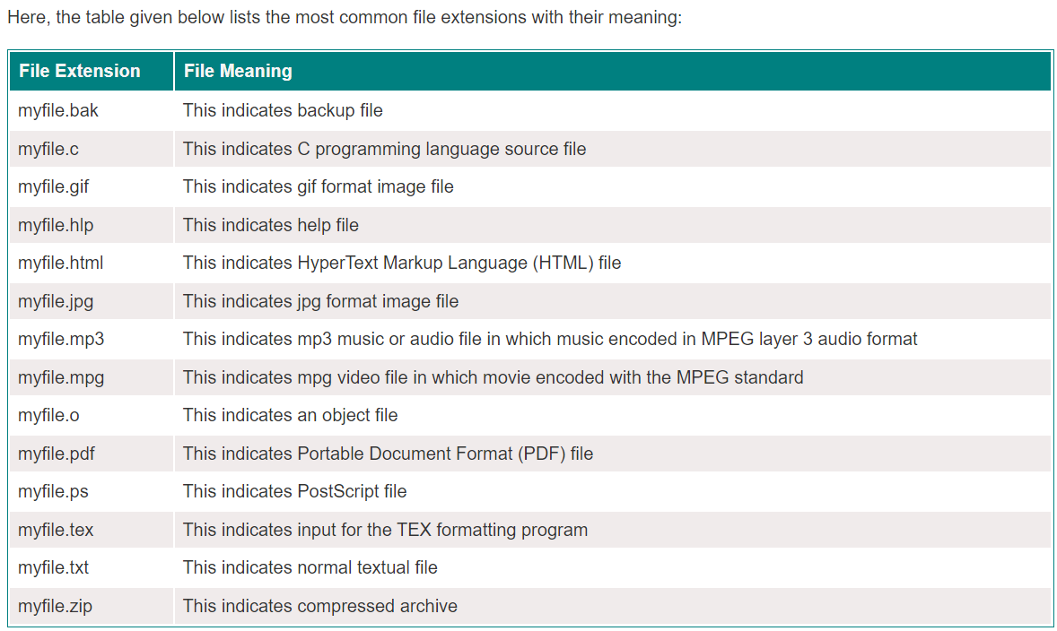

5.2 File Operation

A file is a collection of logically related data that is recorded on the secondary storage in the form of sequence of operations. The content of the files are defined by its creator who is creating the file. The various operations which can be implemented on a file such as read, write, open and close etc. are called file operations. These operations are performed by the user by using the commands provided by the operating system. Some common operations are as follows:
- Create operation:
This operation is used to create a file in the file system. It is the most widely used operation performed on the file system. To create a new file of a particular type the associated application program calls the file system. This file system allocates space to the file. As the file system knows the format of directory structure, so entry of this new file is made into the appropriate directory.
- Open operation:
This operation is the common operation performed on the file. Once the file is created, it must be opened before performing the file processing operations. When the user wants to open a file, it provides a file name to open the particular file in the file system. It tells the operating system to invoke the open system call and passes the file name to the file system.
- Read operation:
This operation reads the contents from a file. A Read pointer is maintained by the OS, pointing to the position up to which the data has been read.
- Delete operation:
Deleting the file will not only delete all the data stored inside the file it is also used so that disk space occupied by it is freed. In order to delete the specified file the directory is searched. When the directory entry is located, all the associated file space and the directory entry is released.
- Close operation:
When the processing of the file is complete, it should be closed so that all the changes made permanent, and all the resources occupied should be released. On closing it deallocates all the internal descriptors that were created when the file was opened.
- Rename operation:
This operation is used to rename the existing file.

5.3 File Extension

A file extension or file name extension is the ending of a file that helps identify the type of file in operating systems, such as Microsoft Windows. In Microsoft Windows, the file name extension is a period that is often followed by three characters but may also be one, two, or four characters long. File extensions are used by the operating system to identify what apps are associated with what file types—in other words, what app opens when you double-click the file. For example, a file named “awesome_picture.jpg” has the “jpg” file extension.

File extensions help the file system and users mainly in two ways. First, it helps in identifying the type of data it holds. Second, the file extension allows the operating system to choose the proper application with which to open a file. This is convenient to users and helps in learning and operating on unfamiliar data files with the help of their file extensions.

5.4 File System Layout
A file system is a set of files, directories, and other structures. File systems maintain information and identify where a file or directory's data is located on the disk. In addition to files and directories, file systems contain a boot block, a superblock, bitmaps, and one or more allocation groups. An allocation group contains disk I-nodes (Index node) and fragments. Each file system occupies one logical volume.
Almost all disks can be divided up into multiple partitions with independent file systems on each partition. Here, in the partition of the disk, Sector 0 is called as Master Boot Record (MBR), is used to boot the computer system.

5.4 File allocation: Contagious, Index
The allocation methods define how the files are stored in the disk blocks. There are three main disk space or file allocation methods.

- Contiguous Allocation
- Linked Allocation
- Indexed Allocation
The main idea behind these methods is to provide:
- Efficient disk space utilization.
- Fast access to the file blocks.

1. Contiguous Allocation

In this scheme, each file occupies a contiguous set of blocks on the disk. For example, if a file requires n blocks and is given a block b as the starting location, then the blocks assigned to the file will be: b, b+1, b+2,……b+n-1. This means that given the starting block address and the length of the file (in terms of blocks required), we can determine the blocks occupied by the file.
The directory entry for a file with contiguous allocation contains
- Address of starting block
- Length of the allocated portion.
The file ‘mail’ in the following figure starts from the block 19 with length = 6 blocks. Therefore, it occupies 19, 20, 21, 22, 23, 24 blocks.

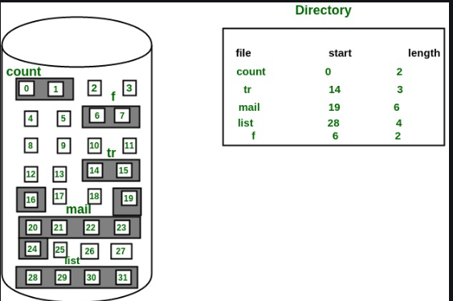
Advantages:
- Easy to implement
- This is extremely fast since the number of seeks are minimal because of contiguous allocation of file blocks.
Disadvantages:

- This method suffers from both internal and external fragmentation. This makes it inefficient in terms of memory utilization.
- Increasing file size is difficult because it depends on the availability of contiguous memory at a particular instance.

2. Non-Contiguous Allocation
Indexed Allocation
In this scheme, a special block known as the Index block contains the pointers to all the blocks occupied by a file. Each file has its own index block. The ith entry in the index block contains the disk address of the ith file block. The directory entry contains the address of the index block as shown in the image:
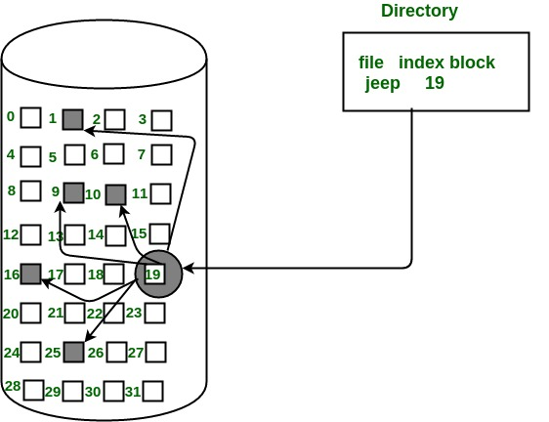

Advantages:
- Supports direct access
- A bad data block causes the lost of only that block.
Disadvantages
- Having an index block for a small file is totally wastage.
- More pointer overhead

5.7 Free Space Management
The system keeps tracks of the free disk blocks for allocating space to files when they are created. Also, to reuse the space released from deleting the files, free space management becomes crucial. The system maintains a free space list which keeps track of the disk blocks that are not allocated to some file or directory. The free space list can be implemented mainly as:
- Bitmap or Bit vector
A Bitmap or Bit Vector is series or collection of bits where each bit corresponds to a disk block. The bit can take two values: 0 and 1: 1 indicates that the block is allocated and 0 indicates a free block.
Advantages
- Simple to understand
- It occupies very less memory.
- Linked List
In this approach, the free disk blocks are linked together i.e. a free block contains a pointer to the next free block. The block number of the very first disk block is stored at a separate location on disk and is also cached in memory.
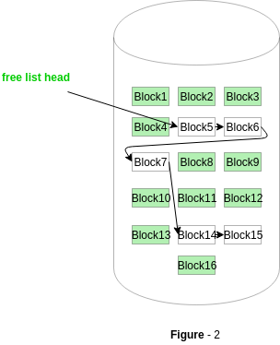
- Grouping
This approach stores the address of the free blocks in the first free block. The first free block stores the address of some, say n free blocks. Out of these n blocks, the first n-1 blocks are actually free and the last block contains the address of next free n blocks.
An advantage of this approach is that the addresses of a group of free disk blocks can be found easily.
- Counting
This approach stores the address of the first free disk block and a number n of free contiguous disk blocks that follow the first block.
Every entry in the list would contain:
- Address of first free disk block
- A number n of free contiguous disk blocks.

